Yashwantrao Chavan College of Science, Karad

Affiliated to
Shivaji University, Kolhapur
B.C.S - II
CBCS (NEP 2020)
Semester – IV
Environmental Studies
A Project Report on
“ STUDY OF IMPACT OF ACID RAIN ON AESTHETIC ROCK’S ”
Submitted by
Sr. No. | Name of the Students | Roll No. | Exam Seat No.
 | Shewale Sanjana Hanmant | 8143 | 1651
 | Shikalgar Saniya Maulaalli | 8144 | 1652
 | Shikalgar Swaliha Ramjan | 8145 | 1689
 | Shinde Aditya Chandrakant | 8146 | 1581
 | Shinde Amruta Sachin | 8147 | 1633

Under the supervision of
Mr. Shaikh Tarbej J.

2024 – 2025


Shri Shivaji Education Society Karad's - Board of Higher Education, Karad
Yashwantrao Chavan College of Science, Karad
Affiliated to Shivaji University, Kolhapur
NAAC Reaccredited as "A+" Grade | AN ISO 9001:2015 Certified College
Certificate
I am pleased to certify that the project entitled " STUDY OF IMPACT OF ACID RAIN ON AESTHETIC ROCK’S " submitted by the following students is an original work carried out by them in fulfillment of the Certificate Course in "Environment Studies" at B.C.S. II level. The work was conducted under my supervision.
Sr. No. | Name of the Students | Roll No. | Exam Seat No. | Signature
 | Shewale Sanjana Hanmant | 8143 | 1651
 | Shikalgar Saniya Maulaalli | 8144 | 1652
 | Shikalgar Swaliha Ramjan | 8145 | 1689
 | Shinde Aditya Chandrakant | 8146 | 1581
 | Shinde Amruta Sachin | 8147 | 1633

Teacher in-charge Head of Dept. of Pollution

Principal

Declaration
We hereby declare that the project entitled " STUDY OF IMPACT OF ACID RAIN ON AESTHETIC ROCK’S " completed and written by us for the Certificate Course in "Environmental Studies," is our original work. We confirm that this project has not been submitted to any other university or examining body for the award of any certificate, diploma, or degree.
Sr. No. | Name of the Students | Roll No. | Exam Seat No. | Signature
 | Shewale Sanjana Hanmant | 8143 | 1651
 | Shikalgar Saniya Maulaalli | 8144 | 1652
 | Shikalgar Swaliha Ramjan | 8145 | 1689
 | Shinde Aditya Chandrakant | 8146 | 1581
 | Shinde Amruta Sachin | 8147 | 1633

Palace: Karad
Date: 30/04/2025

Acknowledgements
We would like to express our sincere gratitude to our Principal, Dr. S. B. Kengar Sir, for providing us with the opportunity to undertake this project.
We are also thankful to our Head of Department of Pollution, Ms. Pushpalata Ghadge Mam, for their guidance and support throughout the project.
We extend our heartfelt thanks to our Teacher-in-Charge, Shaikh sir, for their valuable guidance, supervision, and encouragement. Their expertise and feedback were instrumental in shaping our project.
We appreciate the support provided by our Lab Assistant, who helped us with necessary facilities and technical assistance. We also thank the supporting staff of Pollution Department, Yashwantrao Chavan College of Science, Karad, for their help in various administrative tasks.
Lastly, we would like to thank our classmates and friends for their cooperation, suggestions, and encouragement throughout the project. Their support and camaraderie made this endeavor a memorable and enriching experience.
Palace: Karad
Date: 30/04/2025

Yashwantrao Chavan College of Science, Karad
Department of Pollution
Environmental Studies
STUDY OF IMPACT OF ACID RAIN ON AESTHETIC ROCK’S
Content
Sr. No. | Topic | Page No.
 | Introduction  - Objective  - Hypothesis | 01-05
 | Methodology  - Location & Map  - Sources  - Effects  - Control measures  - Suggestions | 06-09
 | Observations | 10-16
 | Questionary | 17
 | Summary | 18-20
 | Conclusion | 21
 | References | 22-25

INTRODUCTION
Acid rain is one of the most serious environmental problems caused by air pollution. It refers to rainwater that is more acidic than normal due to the presence of sulfur dioxide (SO₂) and nitrogen oxides (NOₓ) released into the atmosphere by industrial activities, vehicles, and power plants. When these gases mix with moisture in the atmosphere, they form sulfuric acid and nitric acid, which fall to the ground as acid rain.
This project focuses on the impact of acid rain on aesthetic rocks—those used in decorative, architectural, and heritage structures, such as marble, limestone, and sandstone. These rocks are commonly found in monuments, temples, museums, buildings, and sculptures that carry cultural, historical, and artistic value.
Acid rain causes chemical weathering of these rocks by reacting with their minerals. For example, the calcium carbonate in marble and limestone reacts with acids to form gypsum, which is soluble in water. This reaction leads to loss of surface material, fading of color, rough textures, and in some cases, complete erosion of fine details like carvings and inscriptions.

In urban areas and industrial regions, this issue is especially severe due to high levels of pollution. Many world-famous structures—such as the Taj Mahal in India, the Parthenon in Greece, and various cathedrals in Europe—have shown visible signs of damage due to acid rain.
The purpose of this project is to:
Investigate the causes and effects of acid rain.
Study how it damages aesthetic rocks.
Explore ways to prevent or reduce this damage.
Raise awareness about the importance of preserving our natural and cultural heritage.
By understanding this problem, we can take steps to protect valuable structures and promote a cleaner, healthier environment for future generations.

- LESHAN GIANT BUDDHA, MOUNT EMEI (China, Buddhist)
Towering above the sheer river gorges of China’s Sichuan province, Mount Emei, one of the “Four Sacred Buddhist Mountains of China”, represents the main seat of Chinese Buddhism.
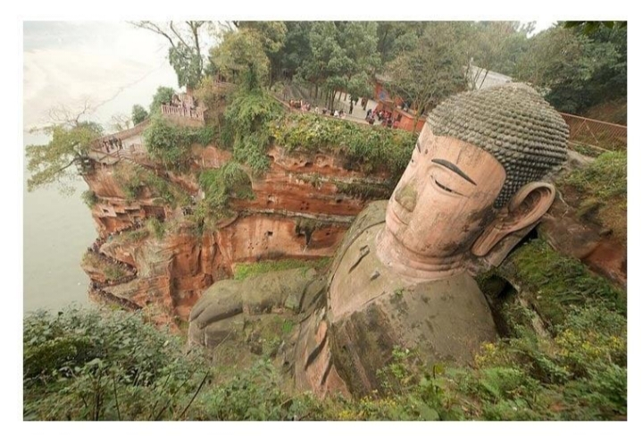
It is home to the country's first Buddhist temple, built in the 1st century C.E., and contains numerous other temples,
monasteries and religious shrines, including the 8th century Leshan Giant Buddha. This Tang Dynasty-era masterpiece
is the world's largest Buddhist statue, reaching an awe-inspiring 71 meters in height and is 28 meters in width. Carved
out of a face of a sandstone cliff facing Mount Emei, the Leshan Giant Buddha is surrounded by spectacularly lush and
breathtaking subtropical and subalpine forests, and rests atop the confluence of three major rivers, the Minjiang, Dadu,
and Qingyi. This site is a place of invaluable religious, artistic and natural significance.
- TAJ MAHAL (India, Mughal Islam)
Located in Agra, India, the Taj Majal is a huge mausoleum built between 1631 and 1648 in the Mughal architectural style, combining elements of Turkish, Indian, Persian, and Islamic design. Considered to be the penultimate masterpiece of Islamic architectural art in India, it was built by Shah Jahan for his wife Mumtaz Mahal, and both are interred in it in a simple crypt. The Taj Mahal is India’s preeminent tourist destination, attracting between two and four million visitors annually. In an effort to control the deleterious effects of pollution, tourist traffic is not allowed near the site, with most visitors riding in by electric bus from nearby carparks.


This has not however, slowed down the degradation of the Taj Mahal’s marble facades from acid rain generated from local foundries and an oil refinery. The once brilliant-white Taj has been losing its luster, dulling into a sickly pale shade.

  - Objective :
To study the impact of acid rain on aesthetic rocks (decorative stones and monuments), understand the sources and chemical nature of acid rain, and analyze the extent of damage and possible preventive measures.

1.2 Hypothesis:
Acid rain chemically reacts with minerals in aesthetic rocks, leading to physical erosion, color fading, and surface roughness, ultimately degrading their appearance and historical value.

Methodology

2.1 Location & Map:
Study locations include public monuments, buildings with marble/granite facades, and temples in urban and semi-urban areas affected by industrial pollution (e.g., Mumbai, Pune, or local sites near Karad). Attach a map highlighting these areas.
Location of Indian



2.2 Sources :
Industrial emissions (SO₂, NOₓ gases) .
Vehicular exhausts .
Thermal power plants .
Acidic pollutants carried by wind and rain .

2.3 Effects :
Chemical Reaction: Sulfuric and nitric acids in acid rain react with calcium carbonate in marble and limestone to form gypsum, which is soluble and gets washed away.
Surface Erosion: Leads to pitting, cracking, and flaking.
Discoloration: Loss of shine, fading of color.
Loss of Artistic Detail: Especially in sculptures and engravings.
Weakened Structure: Long-term exposure weakens rock integrity.
In today’s world due to rapid industrialization and to cope up with the demand of this exponentially growing population we have completely ignored the consequences of such actions on nature which ultimately resulted in causing serious damage to our environment. Acid rain is one such phenomenon caused due to acidification of rainwater by gases like sulphur dioxides and oxides of nitrogen and ozone to some extent. Such gases are not only released as a by-product from the burning of fossil fuels but also from motor vehicle exhausts (releasing NOx) and smelters (releasing SO2).
These oxides react with each other and form hazardous substances in both dry and wet form which carried along with rainwater droplets and cause acid rain. Acid rain is a common term used for acid deposition in the form of rain, snow, hail etc. This acid precipitation has several profound effects on almost everything ranging from plants, soil to non-living objects like buildings. Here we will only discuss it’s the effect on plants and crop fields.
In plants, acid precipitation causes foliar damage, create disturbance in plant physiological pathways like photosynthesis, nitrogen and sulphur metabolism, leaching of essential nutrients from leaves, cause hindrance in germination. (Varshney et al., 1979). Moreover, this acid precipitation causes soil acidification, improper nutrient supply etc.

2.4 Control Measures :
Reduce emissions by using cleaner fuels.
Install scrubbers in factories to remove SO₂/NOₓ.
Use protective coatings on monuments.
Regular maintenance and restoration.
Promote afforestation to absorb pollutants.
2.5 Suggestion :
Educate the public and industries about pollution control.
Strict implementation of environmental laws.
Use acid-resistant materials in new constructions.
Monitor air quality regularly.
Observation
Visible damage on stone surfaces exposed to open environments.
Increased wear on the upward-facing surfaces.
Notable contrast between protected and exposed areas of monuments.
Acid rain observation involves measuring the acidity of precipitation, typically by determining its pH level. Normal rain is slightly acidic with a pH of around 5.6, while acid rain has a pH below 5. Observation of acid rain often involves collecting rainwater samples and analyzing their pH using equipment like pH meters.
Elaboration:
1. Measuring Acidity:
Acid rain observation primarily focuses on determining the pH level of precipitation. Normal rainwater has a pH of approximately 5.6 due to the presence of dissolved carbon dioxide, which forms a weak acid. Acid rain, however, has a pH below 5, indicating a higher concentration of hydrogen ions and therefore a more acidic nature.
2. Sampling and Analysis:
To observe acid rain, scientists collect rainwater samples using specialized equipment like rain gauges. These samples are then analyzed in laboratories using pH meters to determine the pH level.
3. Monitoring Networks:
Various organizations, like the US Environmental Protection Agency (EPA), operate monitoring networks to track acid rain and its impact on the environment. These networks often involve collecting.rainwater samples from multiple locations to assess regional trends in acid rain.
4. Observing Effects:
Observation of acid rain is not just about measuring pH; it also involves observing the effects it has on the environment. These effects include damage to trees and crops, harm to aquatic ecosystems, and corrosion of materials like metals and stone.
5. Acid Rain Formation:
Acid rain is formed when pollutants like sulfur dioxide (SO2) and nitrogen oxides (NOx) are released into the atmosphere and react with water vapor to form sulfuric and nitric acids, which then fall to the ground as acid rain .
6.Historical Context:
The concept of acid rain was first recognized in the mid-19th century by scientists who noticed the effects of acidic rain on plants and structures near industrial areas. Further research and monitoring efforts have since expanded our understanding of acid rain and its impacts .

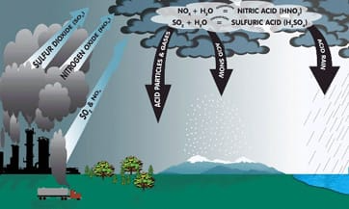
The term acid rain was coined by him in the 1800s. He observed that acidic rain was more prevalent in regions with higher air pollution. The study confirmed the observation made by Robert Angus. Acid rain is created when nitrogen and sulfur dioxides are emitted into the atmosphere .

1 ) MARBLE

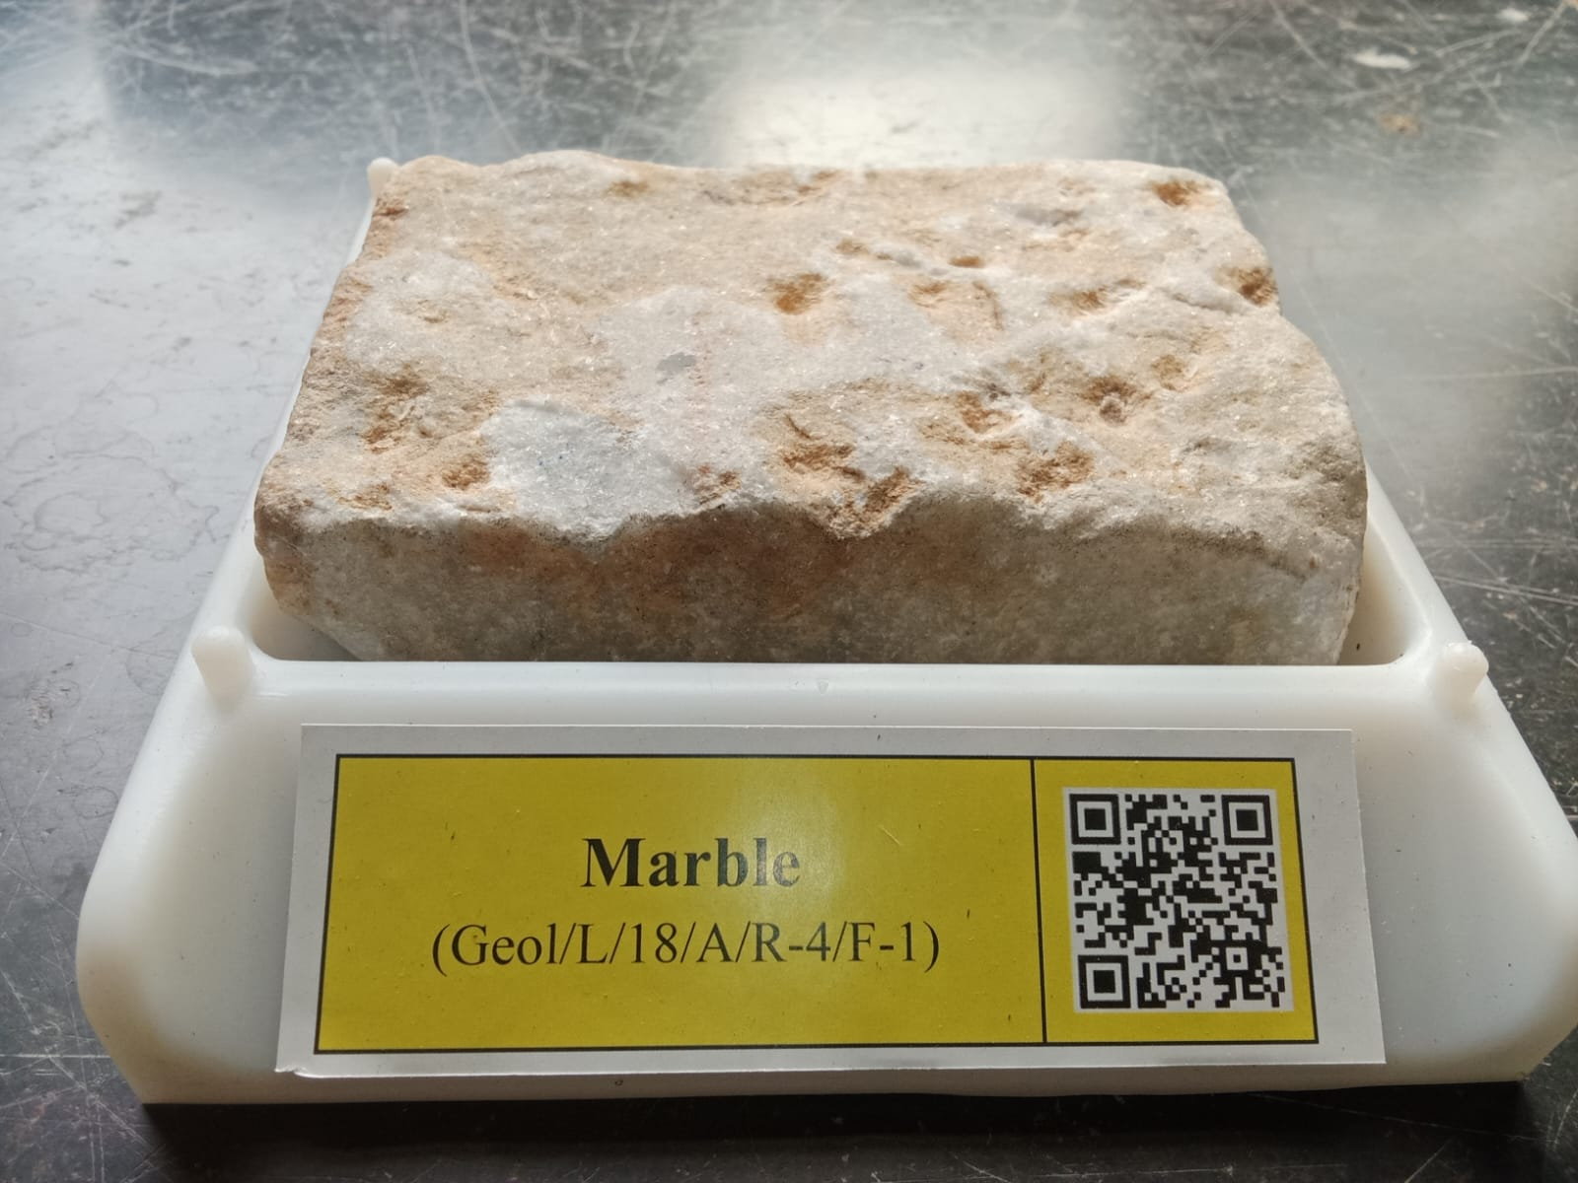

Marble is a metamorphic rock consisting of carbonate minerals (most commonly calcite (CaCO3) or dolomite (CaMg(CO3)2) that have recrystallized under the influence of heat and pressure.[1] It has a crystalline texture, and is typically not foliated (layered), although there are exceptions.

2) FERRUGINOUS SANDSTONE

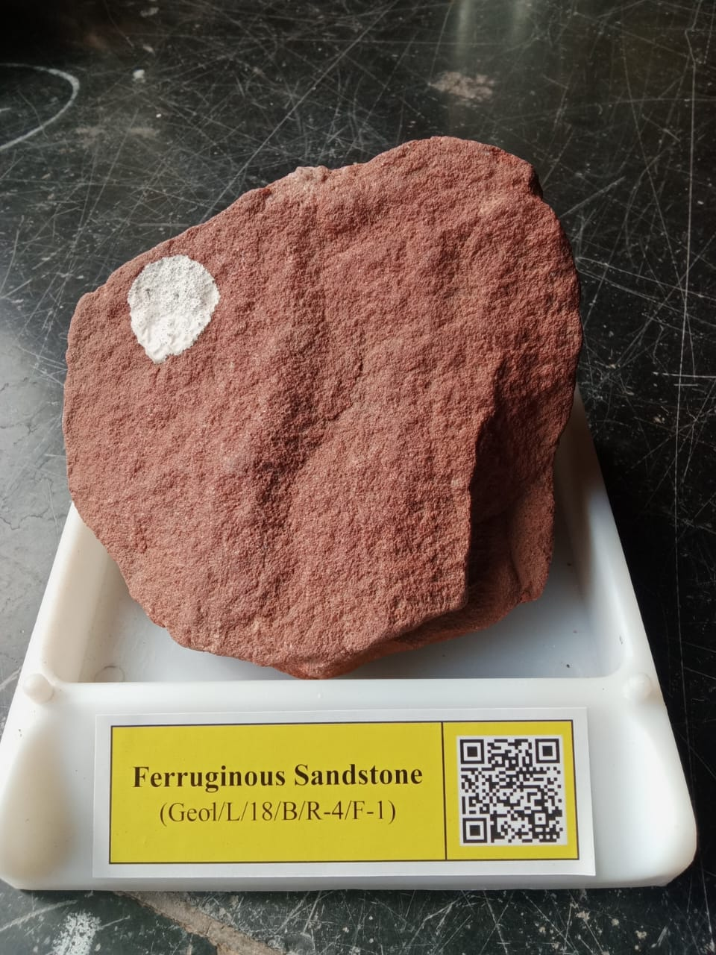
Sandstone from the Triassic of Pennsylvania, USA. (public display, Geology Department, Wittenberg University, Springfield, Ohio, USA) Sedimentary rocks form by the solidification of loose sediments. Loose sediments become hard rocks by the processes of deposition, burial, compaction, dewatering, and cementation.
2) LIMESTONE

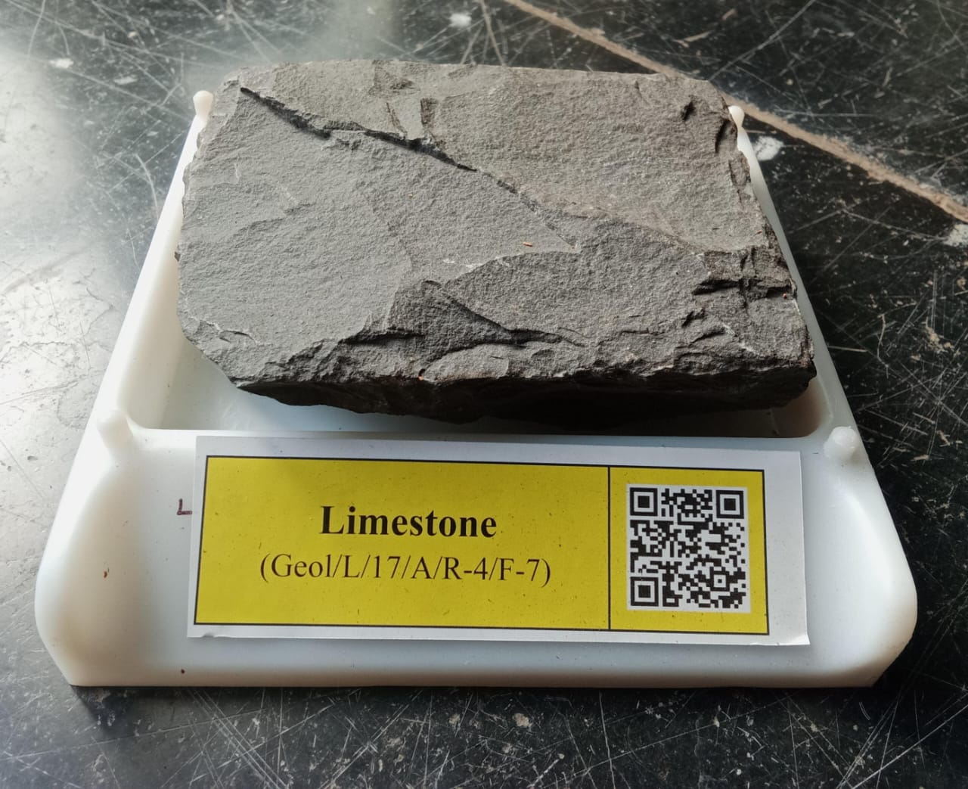

Limestone (calcium carbonate CaCO3) is a type of carbonate sedimentary rock which is the main source of the material lime. It is composed mostly of the minerals calcite and aragonite, which are different crystal forms of CaCO3. Limestone forms when these minerals precipitate out of water containing dissolved calcium. This can take place through both biological and nonbiological processes, though biological processes, such as the accumulation of corals and shells in the sea, have likely been more important for the last 540 million years .Limestone often contains fossils which provide scientists with information on ancient environments and on the evolution of life.[
Questionnaire
(Sample questions for locals/officials)
1. have you observed any change in the appearance of local monuments?
Yes (76 %)
No (12%)
Not Observed (12%)
2. Are there any restoration efforts being made?
Yes (75 %)
No (13%)
Not Observed (12%)
3. Are there industries or heavy traffic nearby?
Yes (50 %)
No (25%)
Not Observed (25%)

4. Is there awareness about acid rain in the community
Yes (60 %)
No (20%)
Not Observed (40%)
5. You can clean or maintain stone structures ?
Yes (70 %)
No (10%)
Not Observed (20%)

6.Definition and sources of acid rain.
Yes (60 %)
No (30%)
Not Observed (10%)
7. Chemical reaction between acid and carbonate rocks.
Yes (75 %)
No (5%)
Not Observed (20%).
9. Comparative analysis of rock durability.
Yes (80 %)
No (20%)
Not Observed (0%)
10. Real-world examples: Taj Mahal, historical buildings in Europe.
Yes (40 %)
No (50%)
Not Observed (10%)

Summary/Suggestions

Acid rain is a major environmental threat to aesthetic rocks, especially those used in heritage structures. It leads to irreversible damage unless proper action is taken. Preventive conservation, pollution control, and public awareness are key.
Acid rain significantly impacts aesthetic rocks by accelerating their weathering and degradation, particularly those made of carbonate materials like limestone. The acidic precipitation dissolves minerals, causing surface damage, loss of detail in carvings, and ultimately leading to structural instability and deterioration of historical monuments and sculptures.
Elaboration:
Accelerated Weathering:
Acid rain's high acidity (pH below 5) reacts with minerals in rocks, like calcium carbonate (CaCO3) found in limestone and marble, causing them to dissolve faster than natural weathering processes.
Surface Degradation:
This dissolution leads to erosion of the rock surface, roughening it and causing a loss of detail in carvings and sculptures.
Crust Formation and Solubilization:
Acid rain can also cause crust formation on the surface of the rock, which can then be solubilized, further damaging the material.
Structural Instability:
The weakening of the rock's structure due to acid rain can lead to cracking, chipping, and even collapse of architectural features and historical monuments.
Metal Corrosion:
Acid rain also corrodes metals used in structures, further contributing to their deterioration.
Examples:
The Longmen Grottoes in China, a UNESCO World Heritage site, have experienced significant damage due to acid rain, including thecollapse of niches and the erosion of sculptures and paintings.
Conclusion
Acid rain significantly affects the aesthetic and structural quality of decorative stones. Immediate and combined efforts from society, government, and scientists are necessary to protect cultural and architectural heritage acid rain is one of the global issues with several adverse impacts on the environment.
Oxides of nitrogen and sulphur dioxide are major gasses behind the formation of acids in the atmosphere responsible for acid rain. Emissions from industries are major sources for sulphur dioxide whereas several fossil fuel combustion activities and vehicular emissions are the major cause for emission of oxides of nitrogen in the atmosphere.
As a result of these gasses acid rain happens after the formation of nitric acid and sulphuric acid. Acid rain causes several environmental problems such as the impact on the forest, crop, building, material, soil/water acidification including health-related issues (respiratory disorder, irritation in eyes and skin infections).
To reduce such type of global problems several strategies have been adopted to reduce the acid rain and its impact on the environment. The effect of acid rain can be lowered by spreading awareness among the people and by the implementation of policies.
Using advanced technology that is cost-efficient and reliable may also decrease acid deployment .The government can make some more strict policie regarding the emission of sulphur dioxide and nitrogen oxide from the transports and industries.

Reference
Abbasi, T., Poornima, P., Kannadasan, T. and Abbasi, S.A. (2013) Acid rain: past, present, and future. International Journal of Environmental Engineering. 5(3): 229-272.
Abrahamsen, G., 1984. Effects of acidic desposition on forest soil and vegetation. Philosophical Transactions of the Royal
and Soil Pollution. 152(1-4): 71-80.
Central Pollution Control Board (CPCB) Reports
Cowling, E.B. and Dochinger, L.S., 1980. "Effects of Acid Precipitation of Health and the Productivity of Forests". In
Environmental Science Resources, Shivaji University, Kolhapur
Fay, J.A., Golomb, D. and Gruhl, J., 1983. Controlling acid rain. Energy Laboratory. Report No. MIT-EL 83-004: 01-41.
Forest and Range Experiment Station.
Gerson, J.R., Driscoll, C.T. and Roy, K.M., 2016. Patterns of nutrient dynamics in Adirondack lakes recovering from acid deposition. Ecological Applications. 26(6): 1758-1770
Hao, J., He, K., Duan, L., Li, J. and Wang, L., 2007. Air pollution and its control in China. Frontiers of Environmental Science & Engineering in China. 1(2): 129-142.
Johnson, D.W., Turner, J. and Kelly, J.M., 1982. The effects of acid rain on forest nutrient status. Water Resources Research. 18(3): 449-461.
Kerr, R.A., 1998. Acid rain control: Success on the cheap. Science. 282(5391): 1024-1024.
Lal, N., 2016. Effects of acid rain on plant growth and development. e. Journal of Science and Technology. 11(5): 85-108.
Lee, J.J., Neely, G.E., Perrigan, S.C. and Grothaus, L.C., 1981. Effect of simulated sulfuric acid rain on yield, growth and foliar injury of several crops. Environmental and Experimental Botany. 21(2): 171-185.
Long, R.P., Horsley, S.B. and Lilja, P.R., 1997. Impact of forest liming on growth and crown vigor of sugar maple and associated hardwoods. Canadian Journal of Forest Research. 27(10): 1560-1573.
Ministry of Environment, Forest and Climate Change (MoEFCC) documents
NCERT Environmental Studies Textbook
Proceedings of Symposium on Effects of Air Pollutants on Mediterranean and Temperate Forest Ecosystems, June 22-27, 1980, Riverside, California (Vol. 43, p. 165). US Department of Agriculture, Forest Service, Pacific Southwest
Raut P. D. (2021) Environmental Studies, Shivaji University, Kolhapur
Research papers on acid rain impact on heritage monuments
Saxena, P. and Sonwani, S., 2019. “Criteria Air Pollutants and their Impact on Environmental Health”. Springer. pp. 157.
Singh, A. and Agrawal, M., 2007. Acid rain and its ecological consequences. Journal of Environmental Biology. 29(1): 15.
Singh, B. and Agrawal, M., 2004. Impact of simulated acid rain on growth and yield of two cultivars of wheat. Water, Air,
Sivaramanan, S., 2015. Acid rain, causes, effect and control strategies. Central Environmental Authority, Battaramulla, 1-13.
Smith, R.A., 1872. "Air and rain: the beginnings of a chemical climatology". Longmans, Green, and Company. pp. 24.
Smock, R., 1990. Acid rain bills point to wet-scrubber retrofits. Power Engineering. 94(7): 34-36.
Society of London. B, Biological Sciences. 305(1124): 369-382.
Sonwani, S. and Maurya, V., 2018. Impact of Air Pollution on the Environment and Economy. Air Pollution: Sources, Impacts and Controls. 113.
Tomlinson, G.H., 1983. Air pollutants and forest decline. Environmental science & technology. 17(6): 246A-256A.
Varshney, C.K., Garg, J.K., Lauenroth, W.K. and Heitschmidt, R.K., 1979. Plant responses to sulfur dioxide pollution. Critical Reviews in Environmental Science and Technology. 9(1): 27-49.

